# Sample Space and Probability

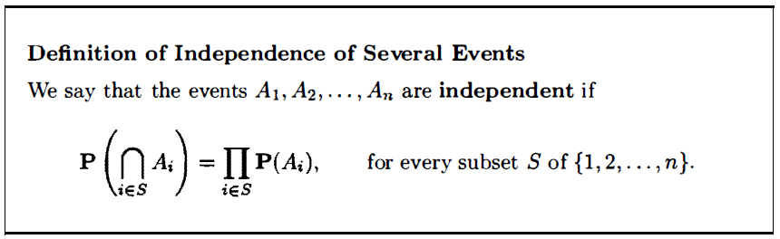

* If the order of selection matters, the selection is called a permutation, and otherwise, it is called a combination.
* In a combination there is no ordering of the selected elements.

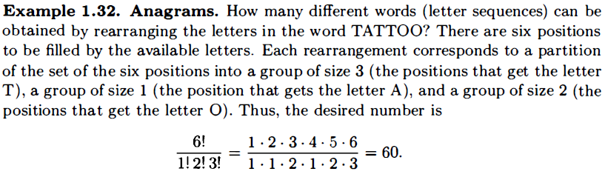

# Discrete Random Variables



